**Report of Anaylsis**

The Final dataframe (csv file) consists of 14 variables that is :

* Tweet_id: the id of the tweet that can be seen in the URL of each tweet.
* Times_stamp: the time and date of the tweet.
* Text: the content of the tweet.
* Name: the name of the dog.
* Breed: the breed of the dog.
* Stage: the current stage [doggo, pupper, puppo, and floof(er)]
* Rating: out of 10 rating and it could be more actually which makes this rating vendor more popular.
* Jpg_url: image of the dog
* Favorite_count: count of likes and favorites
* Retweet_count: count of retweets.
* Following_count: number of friends of the user.
* Application_type: whether it’s an Iphone-Android-Web app.
* Tweet_url: the tweet URL.

Now I have a couple of questions towards this dataset that is :

1. What is the distribution of the ratings? What is the average of the ratings? Probably 9 or 10? Lets plot and get summaries!?

After using Matplotlib I got the following BoxPlot.

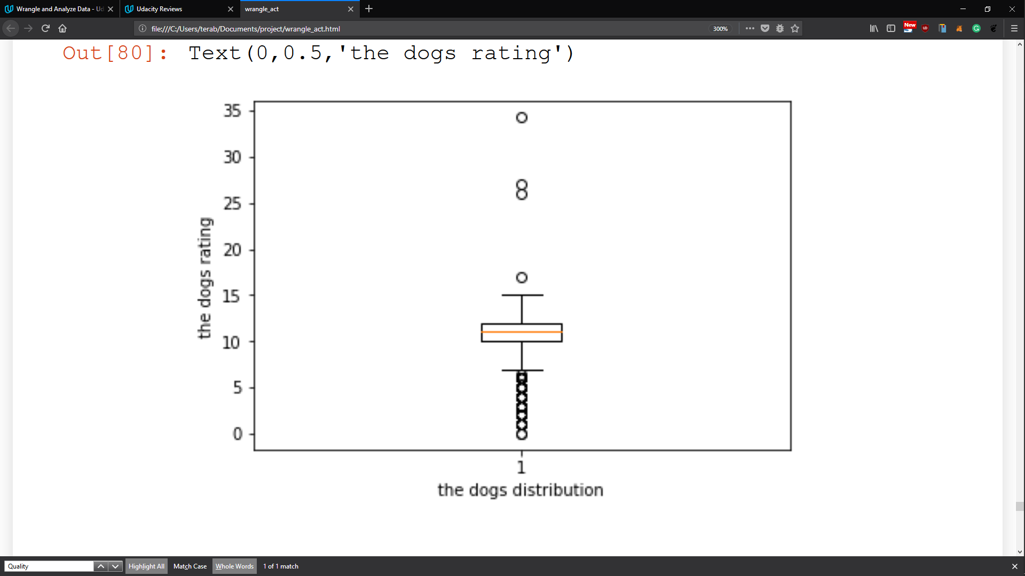

And using Pandas I got that the average of ratings is **12.**

1. What is the most rated breed of dogs?

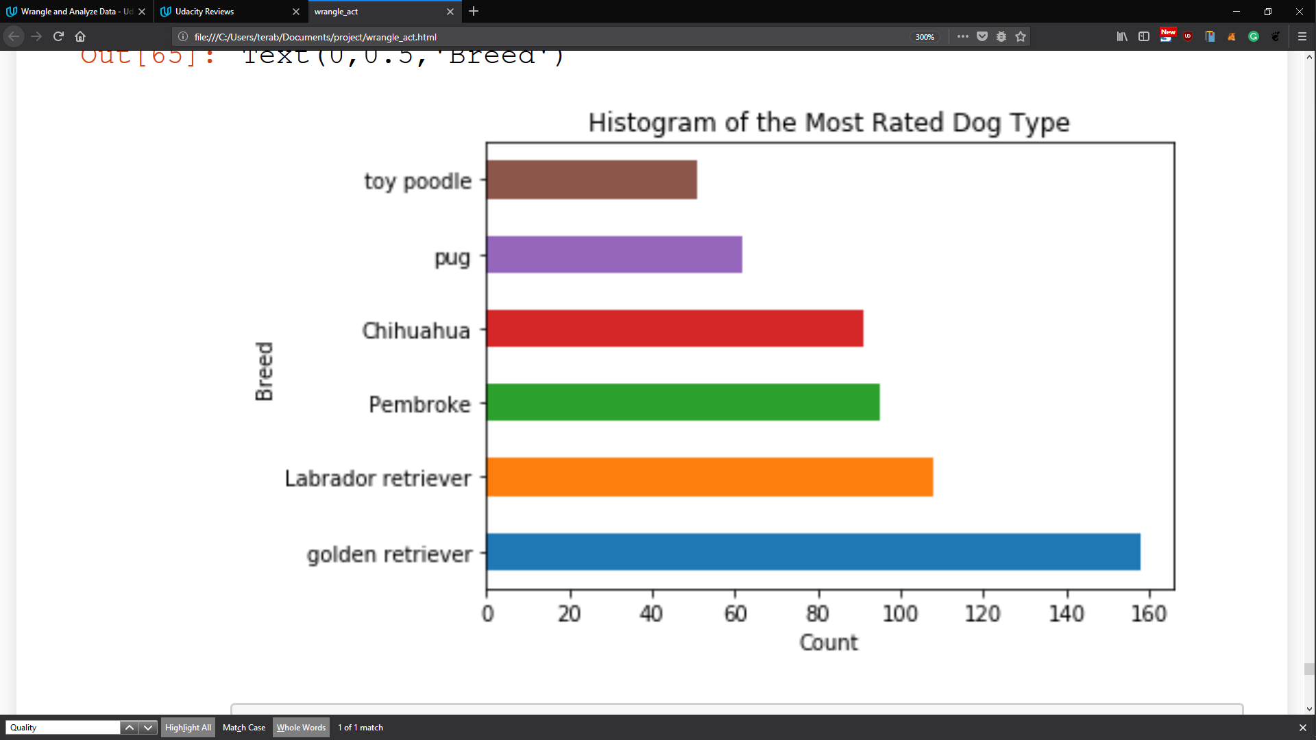

Using Matplotlib Python Package and drawing a Horizontal Bar Chart, I got that the most common breed is the Golden Retriever.

Let’s dig deeper and get some information about that breed.

1. What are the summary stats of the Golden retriever.

Using Pandas package I got the following.

* + There were 158 of Golden Retriever in our dataset that has around 2K of records.
  + the golden retriever is the most common dog with average rating equals to 11.7.
  + the maximum rating was 34/10 which means that it’s a so lovely dog, isn’t it?

1. let’s look for some relationships, the maximum rating number associated with which dog?

Using Pandas library and it’s search functionality we got that it’s called Sam and guess what!

It’s a Golden Retriever dog. [Here](https://pbs.twimg.com/media/C0EyPZbXAAAceSc.jpg) is his pic.